Input of videos/images

↓

Movement to detect joints/key-points [here a heat map is created for each joint for probabilities of where they might be located]

↓

Skeleton images created [for training for yogaposes]

Pose correction

* Can use ST-GCN (takes a sequence of graphs as input) for correction

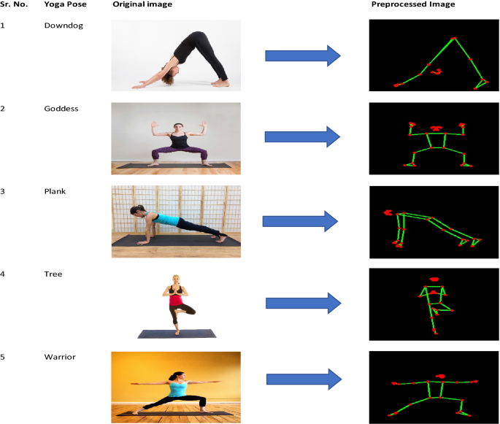

Sequence of graphs generated by CNN

↓

SGC (spatial graph convolution) (processes connections)

↓

TGC (temporal graph convolution)(processes movements)

↓

output of classifying what the movement is

* Use this to first train on correct movements of yougaposes => correct key points and movements are learnt
* In real time => does yoga => processes corrections and movements => calculate relative error => if error > threshold, then feedback